Distance Learning (K-5th grade) Social Story

My school is practicing distance learning to keep everyone safe.

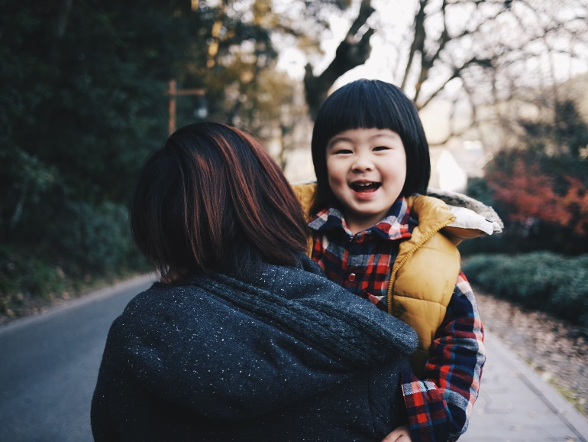

This means I will go to class on the computer.

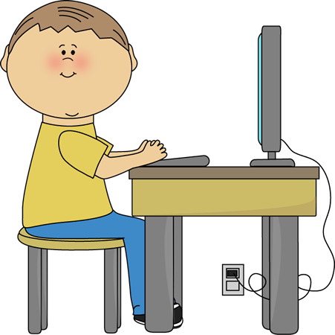

Sometimes, sitting for long periods of time is hard.

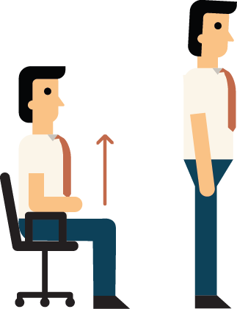

I can ask for breaks.

During class, I will look at the teacher and follow directions.

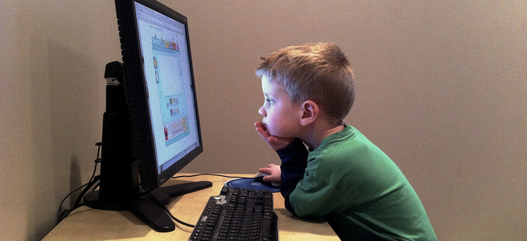

If I need help, I can ask an adult who is home with me.

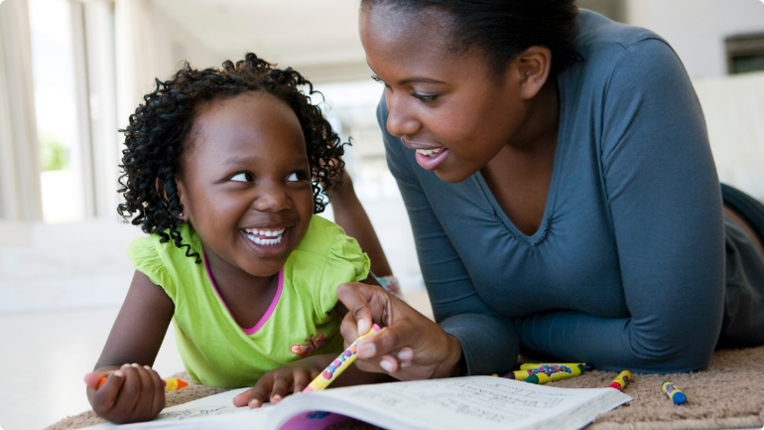

I will follow the rules when doing distance learning.

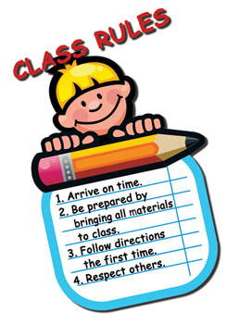

Sometimes distance learning is hard, but I will do my very best.

